Practical-1: Basic Programs Using User-Deƒined Function

1) | Add two numbers using function. (A)
 | Program :-
#include <stdio.h>

void addTwoNumbers(int ,int); //function declaration

void main(){
int n1,n2;
printf("Enter the First Number : ");
scanf("%d",&n1);
printf("Enter the Second Number : ");
scanf("%d",&n2);
//function call
addTwoNumbers(n1,n2);
}

//function Defination
void addTwoNumbers(int a,int b){
printf("%d + %d = %d",a,b,a+b);
}

 | Output :-
 | 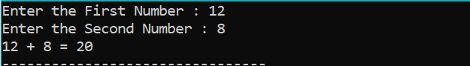
2) | Find maximum and minimum between two numbers using function.?(A)
 | Program :-
#include <stdio.h>

void findMinAndMax(int, int);

void main(){
int n1,n2;
printf("Enter the First Number : ");
scanf("%d",&n1);
printf("Enter the Second Number : ");
scanf("%d",&n2);
findMinAndMax(n1,n2);
}

void findMinAndMax(int a,int b){
if(a > b){
printf("%d is Max.\n",a);
printf("%d is Min.",b);
}
else{
printf("%d is Max.\n",b);
printf("%d is Min.",a);
}
}

 | Output :-
 | 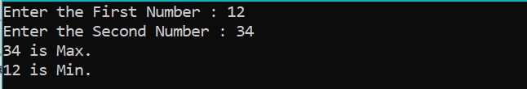
3) | Count simple interest using function.?(A) (I=(p*t*r)/100)
 | Program :-
#include <stdio.h>

void countSimpleInterest(int, int, int);

void main(){
int p,r,t;
printf("Enter the Principal amount : ");
scanf("%d",&p);
printf("Enter the Rate Of Interest : ");
scanf("%d",&r);
printf("Enter the Time (In year) : ");
scanf("%d",&t);
countSimpleInterest(p,r,t);
}

void countSimpleInterest(int p,int r,int t){
float interest = (p*r*t)/100.0;
printf("Interest = %f",interest);
}

 | Output :-
 | 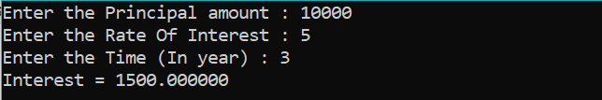
4) | Generate Fibonacci series of N given number using function name ƒbbo().?(B)
 | Program :-
#include <stdio.h>

void fbbo(int);

void main(){
int n;
printf("Enter the Number : ");
scanf("%d",&n);
fbbo(n);
}

void fbbo(int n){
int p1 = 0,p2 = 1,sum = 0;
printf("\n 0 1 ");
int i = 0;
for(i=0;i<n-2;i++){
sum = p1 + p2;
printf("%d ",sum);
p1 = p2;
p2 = sum;
}
}

 | Output :-
 | 